1) Identify a specific interface, which requires some improvement. You must conduct research into the interface, and then redesign the chosen interface with your knowledge. Outline when, how and why this interface is used.

The interface that we decided to improve on is the Google news site, which can be found at <https://news.google.ie>. Google news beta was launched in 2002 and became officially available to everyone in 2006.

Currently the layout is very cluttered and doesn’t draw the users attention. To improve this website we would implement a more graphic interface where the user would be drawn to headlines along with an image where currently there is just a headline in plain text.

Google news is used by users of all ages to keep updated with current affairs on a daily basis.

2) What methods are you going to use to gain more knowledge of this type of system?

Internet Research, use of similar systems, interviews and journal articles?

To gain more knowledge of this type of system we compared the Google news site with other news sites such as BBC News, Sky News and RTE News. From first viewing it was obvious that the Google news site lacked creativity. The site didn’t have the required impact for news site to draw the users attention.

3) What *process* or *life cycle* is the most suitable for the redevelopment of your system? Why is this one more suitable than others? How is usability factored into the process?

For this project, Iterative would be the most suited for a small inexperienced team since they can focus on specific features based on priority and usefulness and improve it over time where as with other life-cycle techniques that would require a lot of time and resources to have an initial draft of the site. Iterative life cycle also allows the team to be flexible in terms of deadline. A few factors for choosing this life cycle would be that once you have initial site up and running you can then get feedback from the public on how you may improve each category and fewer resources are consumed throughout the cycle.

Getting the users feedback and suggestions for new features and how the site can be improved factors usability.

4) Discuss the different types of requirements that are currently in this system. Through what methods have you identified these? Draw a use case diagram for your system. We used task analysis as a method to identify these user requirements.

To name a few requirements currently in the system, the ability to sort news categorically depending on the topic and also the ability to update the latest news into the website for users to see.

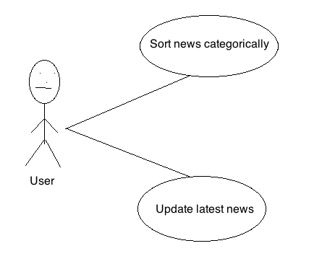

5) What user groups is your choice of interface focused on?

The main focus of the site would be towards a wide variety of groups including people of all ages. Anyone interested in latest news about current affairs, business, sports, politics and technology to name a few have access to these categories instantly.

There is no specific age group that would be interested in the news as it is aimed at the general public. The main requirement would be that the user could use a computer and search the Internet.

6) What changes have you decided to make? Use at least one interaction model (7 stages of action/keystroke level model) and one set of principles/guidelines to analyze the current interface.

The changes made would be that instead of the current system where the foundation of the layout is based on text we would introduce more eye-catching images along with main headlines where the user can then click on the image to be directed to a more detailed article.

I will be analyzing certain aspects of the Google News site based on Donald Norman’s 7 stages of action.

|  |  |
| --- | --- |
| Stage | Device Stage |
| Goal | To deliver news. |
| Intention To Act | Use the website to bring the latest news. |
| Sequence Of Actions | Search for Google news. Choose the news category. Browse latest news. |
| Execution Of The Action Sequence | Execute action in previous steps. |
| Perceiving The Real World | Article delivered/read. |
| Interpreting The Perception | Articles not delivered correctly. |
| Evaluation Of Interpretations | Internet connection not available. |

The initial interface you first meet does not have strong visibility (relevant parts visible). Different news categories are not clearly separated and there is too much plain text. When a link is clicked feedback from the site is good and it redirects you to the intended article. One thing that could be added is some sort of audio to confirm to the user that their request is being processed after they click a link. The mapping and navigation on the site is effective and easy to use. The theme followed is consistent in how it visually looks but is ineffective.

7) Create a brief initial low fidelity prototype to be used for product conceptualization.